IPMC

Community 25 Tema

Email: [training@ipmcghana.com](mailto:training@ipmcghana.com)

Harmony Estate Management Website.

BY Narhbi Elia

Level One Project,

(SEM 1 SWE PROJECT WORK).

[elianarhbi800@gmail.com](mailto:elianarhbi800@gmail.com)

DECLARATION

I Narhbi Elia l hereby declare that except for references to other people's work which have been duly acknowledged, this except is a result of my own research. No part of this work has been presented anywhere for certification.

**TABLE OF CONTENTS**

**Title Page…………………………………………………………………………..**

**Declaration…………………………………………………………………………**

**Introduction………………………………………………………………….**

**Abstract……………………………………………………………………………..**

**Objective and Scope…………………………………………………………………**

**Limitation…………………………………………………………………………………**

**Important findings……………………………………………………………………**

**Hardware and Software Requirement ……………………………………..**

**User manual and Sample Output…………………………………………………**

**Requirements Analysis……………………………………………………………..**

**Process model…………………………………………………………**

**Source Code…………………………………………………………………………**

**Glossary………………………………………………………………………………..**

**Conclusion……………………………………………………………………………….**

**ABSTRACT**

The Harmony Estate Management Website Documentation is a comprehensive guide for users, administrators, and developers. It covers the website's purpose, user interface, and key features for efficient estate management. The document provides insights for administrators on system configuration and security, while developers can explore the technology stack and customization options. Emphasis is on creating a harmonious user experience and optimizing efficiency. Overall, it serves as a vital resource for stakeholders involved in estate management**.**

**Introduction**

In an era marked by rapid technological advancements, the world is witnessing a remarkable evolution in the way information is shared and accessed. This digital transformation has woven itself into the fabric of our daily lives, reshaping how we engage with the world.

Harmony Estate, nestled in its serene and contemporary setting, stands as a beacon of modern community living. It embraces technology as a tool for progress, exemplified by the Harmony Estate Management website. This digital gateway serves as a bridge, ensuring that residents and stakeholders can effortlessly access critical information, stay abreast of community updates, events, activities, and other indispensable details, all from the convenience of their homes or any place with an internet connection.

As you navigate through this documentation, you will delve into the empowering capabilities of the Harmony Estate Management website. Explore how this digital platform fosters a harmonious living experience, keeping residents well-informed, interconnected, and actively engaged. Welcome to the digital realm of harmonious community living at Harmony Estate, where the Harmony Estate Management website acts as your key to a more connected and informed community life.

**Statement of the Problem**

The present endeavor aims to inform, analyze, design, develop, and implement a user-friendly online platform for Harmony Estate. Specifically, this study seeks to answer the following questions:

* Why is it necessary to create a website for Harmony Estate?
* 2. What are the requirements needed in the development and implementation of the proposed Harmony Estate website?
* 3. What is the importance of creating a website for Harmony Estate in relation to residents and community life?
* 4. How effective is the proposed Harmony Estate website in terms of its functionality?

**Objectives**

The development of the Harmony Estate website aims to achieve the following key objectives:

* **Digital Presence.**
* **Information Dissemination**
* **Efficient Property Management**
* **User-Friendly Experience**
* **Data Security**
* **Mobile Responsiveness.**
* **Search Engine Visibility**
* **Effective Communication**

These objectives aim to create a digital platform that enhances community living, property management, and communication within Harmony Estate.

**Significance of study**

**For the Residents:**

* Enhanced Information Accessibility
* Improved Communication
* Community Engagement
* Administrative Efficiency.
* Data Security and Privacy

**For the Real Estate Firm:**

* Enhanced Property Value
* Efficient Management
* Positive Reputation
* Marketing and Attraction
* Cost Savings

**Scope**

First and foremost, the project seeks to usher in a digital era for Harmony Estate by transitioning from traditional methods of community engagement, information dissemination, and administrative processes to a modern digital platform. This transition represents a fundamental shift in how the estate conducts its affairs.

One of the central goals is to enhance information accessibility for both residents and visitors. Through the website, individuals will have easy and immediate access to a wealth of information related to Harmony Estate, including community news, updates, announcements, and details about upcoming events. This accessibility is designed to keep all stakeholders well-informed and connected.

Administrative efficiency is another core objective. The website will introduce automation and streamlining of various administrative tasks within the estate, including but not limited to handling maintenance requests, coordinating events, and efficiently allocating resources. These improvements aim to reduce manual administrative work and enhance overall operational efficiency.

Effective communication is paramount in any community, and the website will facilitate two-way communication between residents and the estate management. This will enable a more efficient exchange of information, feedback, concerns, and suggestions. By providing a digital channel for communication, the project aims to foster open dialogue within the community.

Community engagement is a crucial element of the project. The website will serve as a hub for community activities, clubs, and events, simplifying the process for residents to participate. A user-friendly interface will allow residents to register for events and engage with various community initiatives. The goal is to make participation in community life as straightforward as possible.

Ensuring data security and privacy is of utmost importance. Robust security measures will be implemented to safeguard personal and community-related information shared on the platform. This includes adhering to best practices to protect data and maintain the privacy of residents.

It provides residents with an online platform to access and potentially list properties within the community. This expands the website's scope to offer a valuable resource for both property owners and potential buyers or renters within Harmony Estate.

**Limitations**

* **Limited Interactivity**: HTML and CSS are primarily for structuring and styling web content, which means that the website may have limited interactivity and dynamic features. Complex functionalities and user interactions may not be feasible without additional technologies like JavaScript.
* **Scalability:** A static HTML and CSS website may face challenges when trying to scale or accommodate a growing amount of content or data. Manual updates and maintenance can become cumbersome as the website expands.
* **Data Handling:** Managing and updating property listings and other estate-related information may require manual editing of HTML files, making it less efficient and more prone to errors. There's no built-in database to facilitate data management.
* **Lack of Real-Time Updates**: The absence of server-side scripting means that the website may not provide real-time updates or dynamic content. This can impact the timeliness of information, especially for property listings and announcements.
* **Limited User Interaction**: Interaction with website visitors is limited to basic forms and links. More advanced features like user accounts, dynamic forms, or personalization are not achievable without server-side scripting.
* **Security**: Without server-side scripting and a database, it may be challenging to implement robust security measures, potentially making the website more vulnerable to security threats.
* **Complex Styling:** While CSS is powerful for styling, complex layouts and advanced styling can be challenging to achieve with HTML and CSS alone. This may impact the website's design and visual appeal.
* **Maintenance Overhead:** Manual updates and maintenance of HTML and CSS files can become time-consuming and error-prone, especially as the website's content and requirements grow.
* **Limited Search and Filter Functionality**: Creating advanced search or filter functionality for property listings or other content is not straightforward with static HTML and CSS.
* **SEO and Analytics:** Implementing advanced SEO techniques or integrating analytics tools may be limited without server-side scripting and dynamic content.

**Important Findings**

Upon careful investigation, it was discovered that the Harmony Estate management faced challenges related to information management and dissemination. The estate relied on manual processes for handling property listings and community announcements, resulting in inefficiencies and difficulties in maintaining up-to-date information. Additionally, the absence of an official website posed obstacles in effectively communicating public information and updates to the community.

Recommendations

* Undertake a comprehensive digital transformation, with the development of a user-friendly website as the central hub for property listings and community updates.
* Implement a Content Management System (CMS) for streamlined content management and timely updates.
* Ensure the website is mobile-responsive to accommodate users on various devices.
* Prioritize security measures, including encryption and secure login systems, to protect user data.
* Maintain a schedule for regular website updates and content refreshment.
* Actively promote the website within the Harmony Estate community and to potential property buyers.
* Implementing these recommendations will facilitate a more efficient and digitally-driven management approach, improving information dissemination and communication while creating a valuable digital resource for the community.

**Impact**

1. Impact on the Real Estate Firm:
   * + **Efficient Property Management**: The website streamlines property management processes, making it easier for the real estate firm to list and update properties, reducing manual workload, and minimizing errors.
     + **Enhanced Marketing**: It provides a digital platform for effectively marketing available properties to a broader audience, potentially leading to increased sales and occupancy rates.
     + **Data-Driven Decision Making:** The website can offer insights and data on user interactions, helping the real estate firm make informed decisions and tailor services based on user preferences and behaviors.
     + **Improved Reputation**: A well-managed website reflects positively on the real estate firm, enhancing its reputation and credibility.

2. Impact on Residents:

* + - **Easy Access to Information:** Residents benefit from convenient access to property listings, community announcements, and essential information, making it easier to stay informed about estate-related matters.
    - **Streamlined Communication**\*: The website serves as a communication channel for residents to interact with estate management, report issues, and receive updates, improving overall community engagement.
    - **Enhanced Living Experience**: Residents can explore community initiatives, events, and updates, contributing to a more enjoyable and connected living experience.
  1. Impact on Visitors:
* **Efficient Property Search:** Potential property buyers or renters benefit from a user-friendly platform for searching and viewing property listings, facilitating the decision-making process.
* **Information Accessibility:** Visitors can access detailed information about the estate, its amenities, and available properties without the need for face-to-face interactions.
* **Convenience**: The website provides a convenient way for visitors to inquire about properties, request additional information, and schedule viewings.
* **Positive Impressions**: A well-designed website can leave a positive impression on visitors, enhancing their perception of the estate and its management.

**Requirement Analysis**

* **Define Project Objectives**:

Clearly define the purpose and objectives of the harmony management website. What is its primary goal? Who is the target audience?

* **Identify Stakeholders**:

Determine who the key stakeholders are, such as users, administrators, managers, and other relevant parties. Understand their needs and expectations.

* **Conduct User Research:**

Perform user research to understand the preferences, pain points, and expectations of the website's primary users.

* **Functional Requirements:**

Identify the core features and functionalities the website needs to have. These might include:

User registration and login

Profile management

Harmony event scheduling

* **Design and User Interface Requirements**:

Define the visual and interactive design elements, including:

Color schemes

Typography

Layout and navigation

Icons and graphics

* **Content Requirements:**

Specify the types of content that will be included on the website, such as text, images, videos, and audio files.

* **Data Management:**

Discuss how user data will be collected, stored, and managed, including considerations for data privacy and GDPR compliance.

* **Maintenance and Support**:

Discuss post-launch support, including bug fixes, updates, and ongoing maintenance.

* **Timeline and Budget:**

Establish project timelines and budget constraints to manage resources effectively.

* **Documentation:**

Create comprehensive documentation that outlines the requirements, design, and development specifications for the project.

* **Review and Approval**:

Present the requirements to stakeholders for review and approval to ensure alignment with their expectations.

**Process model:**

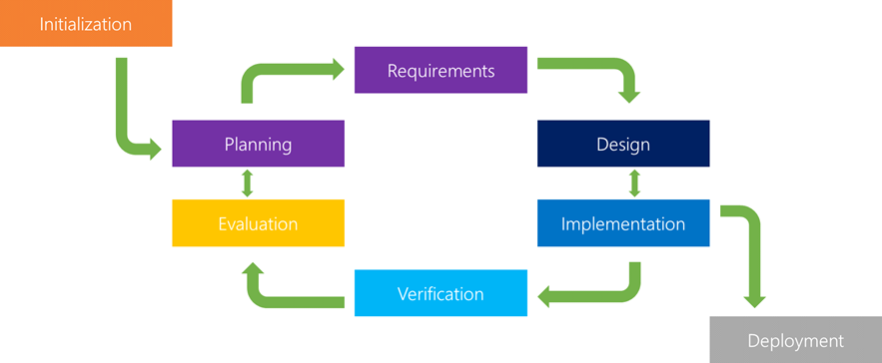

**Initial Planning:**

In the initial planning phase of the Harmony Estate project, the researcher took on the responsibility of both creating comprehensive documentation and developing the application. This solo approach was adopted to ensure a cohesive and unified vision throughout the project's lifecycle.

**Planning and Requirements**:

During this crucial phase, the Harmony Estate project began with the gathering and analysis of software requirements. The researchers dedicated efforts to understand the needs and expectations of the project, resulting in the production of a definitive and conclusive specification of requirements.

With a clear understanding of what the Harmony Estate application needed to achieve, the researchers proceeded to make informed decisions regarding the tools and methods to be employed in the development process.

**Analyses and Design:**

In the analysis and design phase, researchers carefully chose a programming language for comfort and proficiency. They then seamlessly moved into prototyping, design, and coding. Rigorous testing followed, ensuring that the system's components worked cohesively and met predefined standards for readiness.

**Testing and Deployment:**

In the testing and deployment phase, researchers ensured a fully functional software application through simultaneous testing, bug resolution, and the addition of features. The evaluation phase focused on continuous operation, maintenance, and user feedback to refine and improve the Harmony Estate application for better alignment with user needs.

**Evaluation:**

Evaluation involves a comprehensive assessment of the Harmony Estate website, encompassing its operation, maintenance, and user feedback. This phase aims to refine and enhance the software continually, ensuring it remains responsive to user needs and expectations.

**Software Requirement**

Software requirements for the Harmony Estate Management website encompass critical aspects such as hardware interaction, external interface integration, performance standards, system response times, portability, maintainability, recovery speed, security, quality, and limitations. These requirements, initially expressed in natural language by the client, are translated into technical language by the system analyst. This conversion facilitates clear comprehension and effective utilization by the software development team, serving as a blueprint for the creation of a functional and user-friendly website that meets the needs of estate management and residents.

|  |  |
| --- | --- |
| Logo | Tasks |
|  | **Microsoft Office Word** is used in making the documentation of this study. Microsoft Word 2010 |
|  | **HyperText Markup Language** is the main markup language for displaying web pages and other information that can be displayed in a web browser |
|  | **Cascading Styling Sheets is used to style web pages written in HTML.** |

**Hardware Requirement**:

Creating the Harmony Estate Management website does not have specific hardware requirements. Virtually any PC with internet connectivity is sufficient, but the performance may vary depending on the computer's power. Therefore, hardware needs should align with the demands of the website's functions and processes.

**User’s Manual with Sample Output**

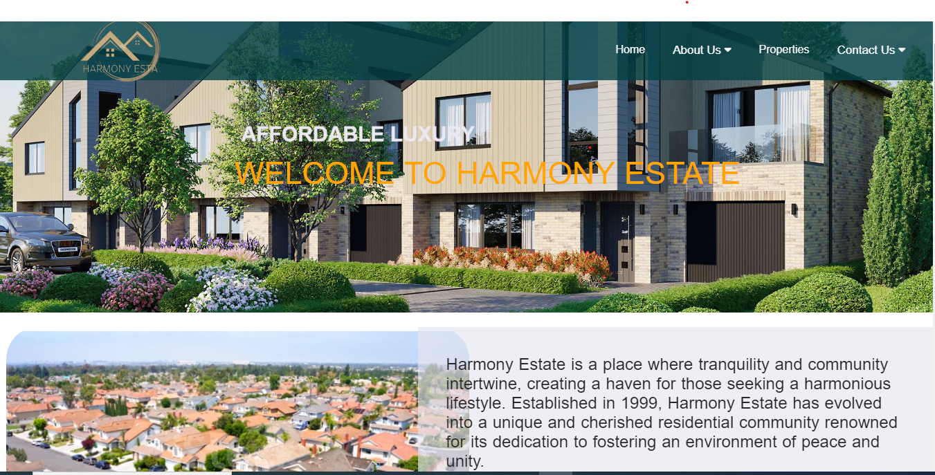

**`**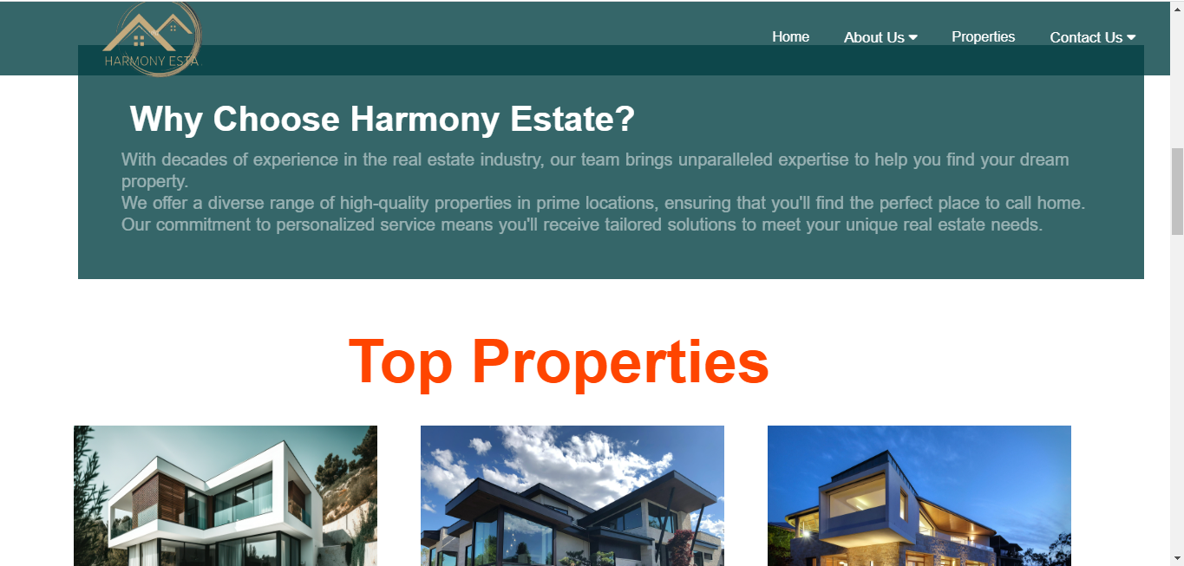

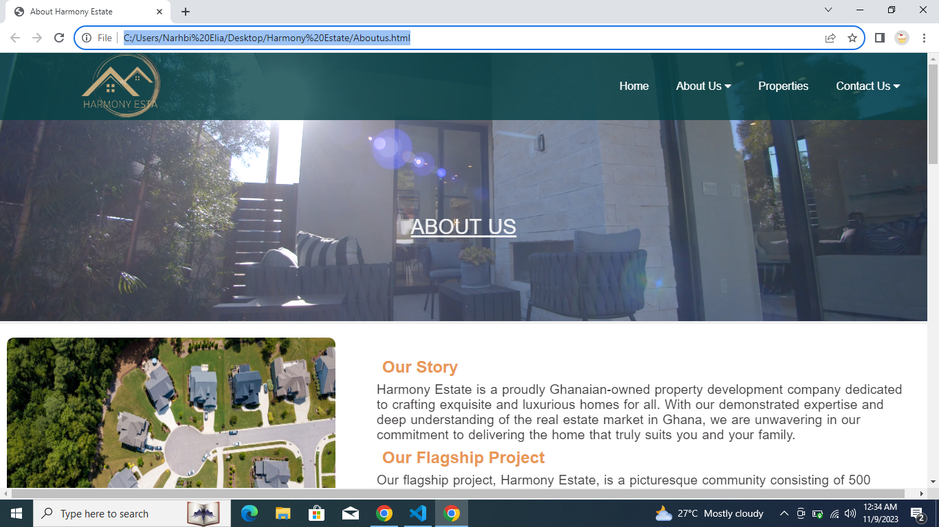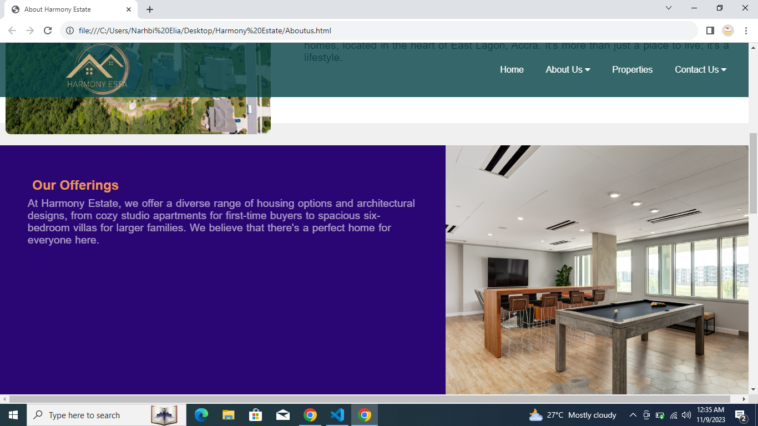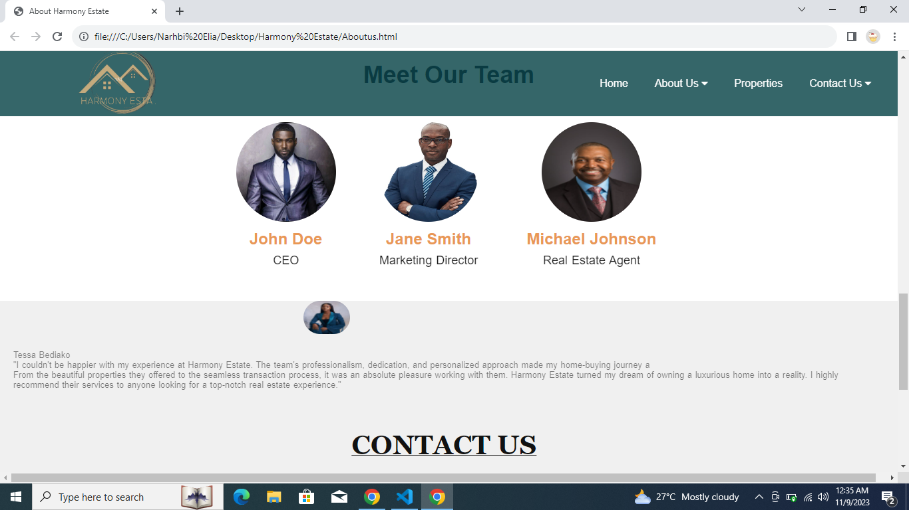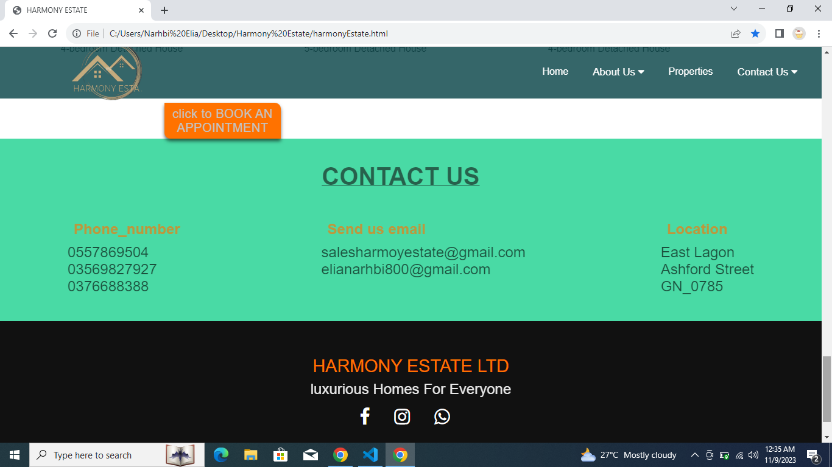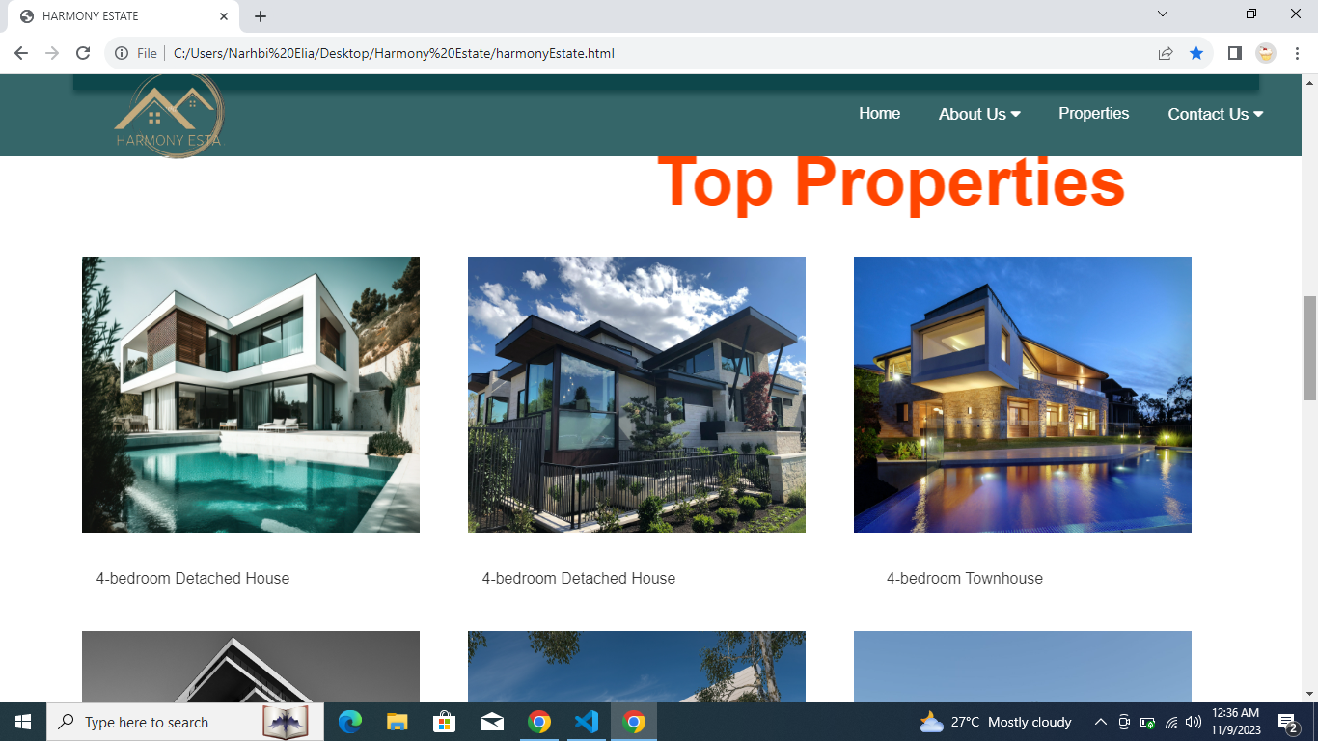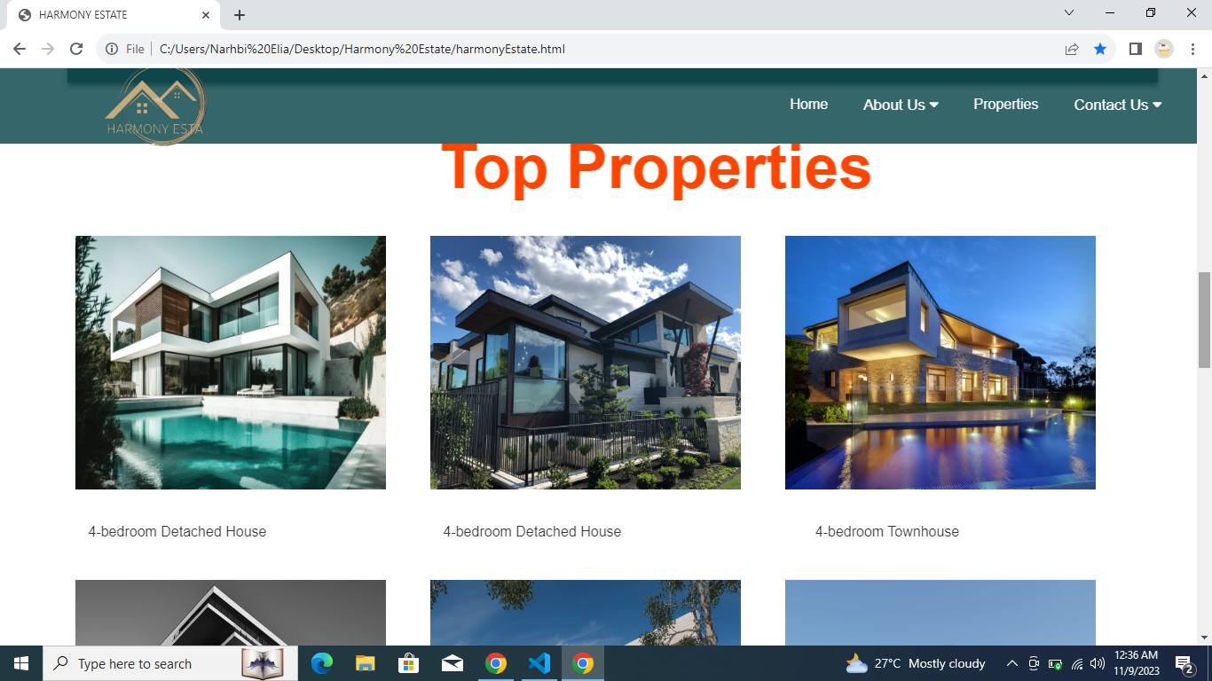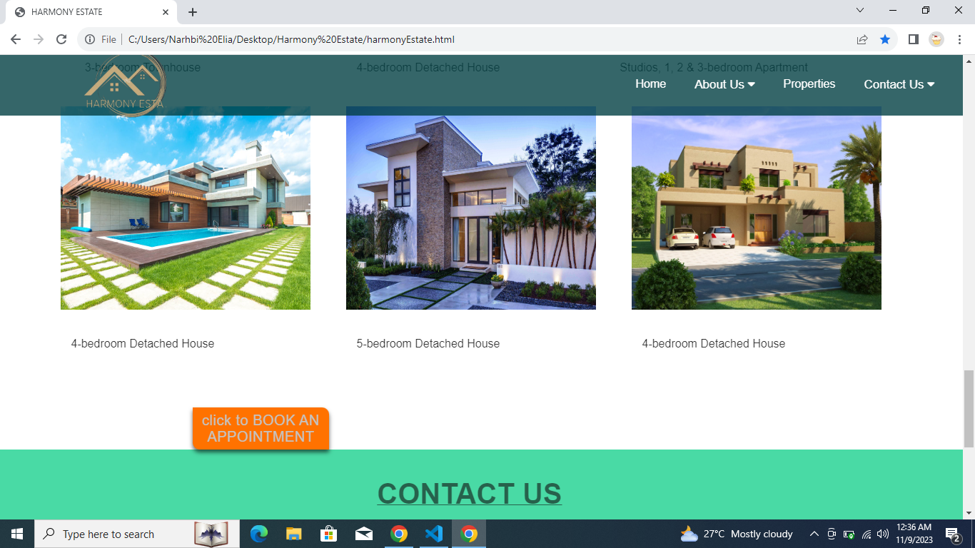

**Web Development Program Code and Sample Output**

**Home Page:**

<!DOCTYPE html>

<html lang="en">

<head>

<meta charset="UTF-8">

<meta name="viewport" content="width=device-width, initial-scale=1.0">

<link rel="stylesheet" href="harmonyEstate.css">

<link rel="stylesheet" href="https://cdnjs.cloudflare.com/ajax/libs/font-awesome/4.7.0/css/font-awesome.min.css">

<title>HARMONY ESTATE</title>

</head>

<body>

<nav>

<div class="logo">

<img src="images/harmonylogo3.png" alt="">

</div>

<ul>

<li><a href="harmonyEstate.html">Home</a></li>

<div class="dropdown">

<li class="dropbtn"> <a href="Aboutus.html">About Us

<i class="fa fa-caret-down"></i>

</a>

<div class="dropdown-content">

<a href="">Testimonials</a>

</div>

</div>

<li><a href="#properties">Properties</a></li>

<div class="dropdown">

<li class="dropbtn"><a href="#contactus">Contact Us

<i class="fa fa-caret-down"></i>

</a>

<div class="dropdown-content">

<a href="contact.html">Email</a>

</div>

</ul>

</nav>

<div class="container">

<div class="slider">

<div class="slide slide1">

<div class="caption">

<h2>AFFORDABLE LUXURY</h2>

<p>WELCOME TO HARMONY ESTATE</p>

</div>

</div>

<div class="slide slide2">

<div class="caption">

<h2> OWN YOUR DREAM HOUSE</h2>

<p>WELCOME TO HARMONY ESTATE</p>

</div>

</div>

<div class="slide slide1">

<div class="caption">

<h2 class="animated-caption">AFFORDABLE LUXURY</h2>

<p>WELCOME TO HARMONY ESTATE</p>

</div>

</div>

</div>

</div>

<div class="Getintouch" >

<div class="video-container">

<video autoplay loop muted>

<source src="harmonyariel.mp4" type="video/mp4">

Your browser does not support the video tag.

</video>

</div>

<div class="introcontent">

<p>Harmony Estate is a place where tranquility and community intertwine, creating a haven for

those seeking a harmonious lifestyle. Established in 1999, Harmony Estate has evolved into a unique and cherished residential

community renowned for its dedication to fostering an environment of peace and unity. </p>

<a href="book.html"><button class="button">Talk To Us >></button></a>

</div>

</div>

<div class="choose-us-section">

<div class="choose-us-content">

<h5>Why Choose Harmony Estate?</h5>

<p>With decades of experience in the real estate industry,

our team brings unparalleled expertise to help you find your dream property.</p>

<p>We offer a diverse range of high-quality properties in prime locations,

ensuring that you'll find the perfect place to call home.</p>

<p>Our commitment to personalized service means you'll receive tailored solutions to meet your unique

real estate needs.</p>

</div>

</div>

<div id="properties">

<h3 class="props"> Top Properties</h3>

<div class="design">

<div class="gallary">

<img src="images/pascal.jpg">

<div class="desc"> 4-bedroom Detached House

</div></div>

<div class="gallary">

<img src="images/harmonyimg14.jpg">

<div class="desc">4-bedroom Detached House

</div></div>

<div class="gallary">

<img src="images/harmonyimg12.jpg">

<div class="desc">4-bedroom Townhouse

</div></div>

<div class="gallary">

<img src="images/harmanyp1.jpg">

<div class="desc">2 & 3-bedroom Townhouse

</div></div>

<div class="gallary">

<img src="images/harmonyp2.jpg">

<div class="desc">2 & 4-bedroom Detached House

</div></div>

<div class="gallary">

<img src="images/harmony3.jpg">

<div class="desc">6-bedroom Detached House

</div></div>

<div class="gallary">

<img src="images/harmonyp4.jpg">

<div class="desc">

3-bedroom Townhouse

</div></div>

<div class="gallary">

<img src="images/haven.jpg">

<div class="desc">4-bedroom Detached House

</div></div>

<div class="gallary">

<img src="images/harmony16.jpg">

<div class="desc">Studios, 1, 2 & 3-bedroom Apartment

</div></div>

<div class="gallary">

<img src="images/harmony15.jpeg">

<div class="desc">4-bedroom Detached House

</div></div>

<div class="gallary">

<img src="images/harmony13.jpg">

<div class="desc">5-bedroom Detached House

</div></div>

<div class="gallary">

<img src="images/harmony14.jpg">

<div class="desc">4-bedroom Detached House

</div></div>

</div>

</div>

<div class="book">

<a href="book.html"><button class=" book-button"> click to BOOK AN APPOINTMENT</button></a></h2>

</div>

<div id="contactus">

<h3 class="consisting"> CONTACT US</h3>

<div class="contact">

<div class="phone_number">

<h2>Phone_number</h2>

<p>0557869504</p>

<p>03569827927</p>

<p>0376688388</p>

</div>

<div class="Email">

<h2>Send us email</h2>

<p>salesharmoyestate@gmail.com</p>

<p>elianarhbi800@gmail.com</p>

</div>

<div class="location">

<h2>Location</h2>

<p>East Lagon</p>

<p>Ashford Street</p>

<p>GN_0785</p>

</div>

</div>

</div>

<div>

<footer >

<div class="footer-content">

<h3>HARMONY ESTATE LTD</h3>

<p>luxurious Homes For Everyone</p>

<ul class="socials">

<li><a href="https://www.facebook.com"><i class="fa fa-facebook"></i></a></li>

<li><a href="https://www.instagram.com/"><i class="fa fa-instagram"></i></a></li>

<li><a href=" https://wa.me/557869504"><i class="fa fa-whatsapp"></i></a></li>

</ul>

</div>

<div>

<div class="footer-body">

<p>copyright &copy;2023 Harmony Estate. All right reserved.</p>

</div>

</footer>

</body>

</html>

CSS Code:

*{

margin: 0;

padding: 0;

box-sizing: border-box;

font-family: Arial, Helvetica, sans-serif;

}

body {

background:white;

width: 100%;

margin: 0;

padding: 0;

}

nav {

position:fixed;

width: 100%;

background-color: rgba(2, 64, 68, 0.8);

color: #ffffff;

display: flex;

justify-content: space-between;

align-items: center;

padding: 10px 20px;

height: 13vh;

z-index: 2;

}

nav ul {

list-style-type: none;

margin: 0;

padding: 0;

display: flex;

}

nav ul li a {

color: #fff;

text-decoration: none;

padding: 10px 20px;

display: block;

}

@media (max-width: 768px) {

nav ul {

flex-direction: column;

background-color: rgba(2, 64, 68, 0.8);

position: absolute;

top: 10vh;

left: 0;

right: 0;

display: none;

}

nav.open ul {

display: flex;

}

}

img {

max-width: 100%;

height: auto;

}

nav ul li a:hover {

background-color: #555;

transition: 0.25s;

}

.dropdown{

color:rgb(39, 36, 36);

font-family: Arial, Helvetica, sans-serif;

float: left;

overflow: hidden;

}

.dropdown .dropbtn{

font-size: 17px;

border: none;

outline: none;

color: rgba(255, 255, 255, 0.7);

background-color: inherit;

font-family: inherit;

margin: 0;

}

.dropdown-content{

display:none;

position:absolute;

background-color: #f9f9f9;

min-width: 160px;

box-shadow:0px 8px 16px 0px;

color: rgba(0,0,0,0.2,);

z-index: 1;

}

.dropdown-content a{

float: none;

color: black;

padding: 12px 16px;

text-decoration: none;

display: block;

text-align: left;

}

.topnav a:hover, .dropdown:hover .droptn{

background-color: indigo;

color:white}

.dropdown-content a:hover{

background-color: #ddd;

color:black

}

.dropdown:hover .dropdown-content{

display: block;}

.logo img {

margin-left:0.9 px ;

margin-top: 40px;

height: 50vh;}

.container{

position: relative;

overflow: hidden;

width:100%;

height:80vh;

}

.container .slider{

position:absolute;

width: 500%;

height: 100%;

animation: animate 30s linear infinite;

}

.container .slider .slide{

width: 20%;

height:100%;

float: left;

}

.container .slider .slide .caption{

position:relative;

margin-top: 20%;

margin-left: 20%;

left:60px;

right: 60px;

padding: 10px;

bottom: 40px;

cursor: pointer;

box-sizing: border-box;

}

.container .slider .slide .caption h2{

justify-content: center;

color:#ebe8f1;

font-size: 30px;

position: relative;

animation: bounce 1s infinite;

}

@keyframes bounce{

0%,100%{transform: translate(0);}

50%{transform: translateY(-20px);}

}

.container .slider .slide .caption p{

color:orange;

font-size: 45px;

}

.container .slider .slide .caption p:hover{

color: #04AA6D;

}

.container .slider .slide.slide1{

background:url(https://www.photoplan.co.uk/wp-content/uploads/2021/05/Architectural_Visualisation_-_500.jpg) ;

background-size: cover;

background-position: center;

}

.container .slider .slide.slide2{

background:url(https://wallpapercave.com/wp/wp3982615.jpg) ;

background-size: cover;

background-position: center;

}

@keyframes animate

{

0%

{

left: 0;

}

20%

{

left: 0;

}

25%{

left:-100%;

}

45%

{

left:-100%;

}

50%

{

left:-200% ;

}

}

.introcontent{

max-width:60vw;

height: 60vh;

background-color:rgba(230, 230, 240, 0.664);

color: rgb(43, 39, 39);

margin-top: 1px;

margin-left:400px;

padding: 40px;

font-size: 1.3 rem;

border-radius:0, 48,48,0;

}

@media (max-width: 768px) {

.introcontent {

width: 90vw;

margin-left: 10px;

font-size: 1rem;

}

}

.button{

background:#ff7200 ;

color:rgb(196, 195, 195);

border: none;

margin-left: 70%;

margin-top:80px ;

font-size : 20px;

height: 9vh;

width:14vw;

letter-spacing: 0.5px;

border-radius:0 10px 0 10px ;

box-shadow: 0 4px 6px rgba(0, 0, 0, 0.6);

cursor: pointer;

transition: 0.3s, color 0.3s;

}

.button:hover{

background:rgb(10, 7, 12);

}

.video-container {

width: 30vh;

height: 60vw;

margin-left: 10px;

}

.video-container video {

width:49vw;

height: 60vh;

border-radius:48px;

}

.Getintouch{

background-color: white;

padding-top: 20px;

margin-bottom: 60px;

color: #e6e0e0;

font-family: Arial, Helvetica, sans-serif;

height:60vh ;

display:flex;

}

.props {

color: orangered;

cursor: pointer;

font-family:sans-serif;

font-size: 70px;

line-height: 90px;

margin-left: 400px;

}

.props {

padding-bottom: 0.25rem;

position: relative;

}

.props::before {

content: "";

position: absolute;

left: 0;

bottom: 0;

width: 0;

height: 2px;

background-color: rgb(96, 100, 96);

transition: width 0.25s ease-out;

}

.props:hover::before {

width: 100%;

}

.marquee {

width: 100%;

overflow: hidden;

}

.props {

display: inline-block;

white-space: nowrap;

animation: marquee 10s linear infinite;

}

@keyframes marquee {

0% {

transform: translateX(100%);

}

100% {

transform: translateX(-100%);

}

}

.design{

max-width: 1200px;

flex-wrap: wrap;

display:flex;

justify-content: center;

}

.gallary{

margin: 5px;

width:390px;

**}**

.gallary img{

width: 100%;

height: 50vh;

padding: 20px;

margin-left: 60px;

cursor: pointer;

}

.gallary img:hover{

opacity: 0.7;

flex: 4;

}

.desc{

padding: 15px;

text-align: center;

opacity: 0.8;

}

.choose-us-section {

padding: 50px;

}

.choose-us-content {

box-shadow: 0 4px 6px rgba(0, 0, 0, 0.6);

background-color: rgba(2, 64, 68, 0.8);;

line-height: 1.25;

font-size:15px;

position: relative;

margin-top: 20px;

margin-left: 26px;

width: 90vw;

padding:50px;

}

h5{

font-size:40px;

color:white;

display: flex;

padding: 10px;

}

.choose-us-content p {

color: white;

word-spacing: 1px;

font-size:20px;

opacity: 0.5;

}

.consisting{

color: #111;

font-size: 40px;

font-family: sans-serif;

margin-left: 75vh;

padding: 40px;

text-decoration-line: underline;

text-decoration-color: #111;

text-decoration-thickness: 1px;

opacity: 0.6;}

.contact{

display: flex;

justify-content: space-around;

margin-bottom: 39px;

opacity: 0.7;

}

p

{

opacity: 0.9;

font-size:1.5rem;

font-family:Arial, Helvetica, sans-serif;

}

h2{

color: #ff7200;

padding: 10px;

opacity: 0.9;

}

#contactus{

background-color: #49daa5;

height: 300px;

}

form {

border: 3px solid #f1f1f1;

font-family: Arial;

width: 23%;

margin-left: 70%;

margin-top: 1px; ;

}

.contain {

padding: 20px;

background-color: #a81e1e;

}

.book button{

background:#ff7200 ;

color:rgb(196, 195, 195);

border: none;

margin-top: 60px;

margin-left: 20%;

font-size : 20px;

height: 9vh;

width:14vw;

letter-spacing: 0.5px;

border-radius:0 10px 0 10px ;

cursor: pointer;

transition: 0.3s, color 0.3s;

box-shadow: 0 4px 6px rgba(0, 0, 0, 0.6);

}

.book button:hover{

background-color: rgb(39, 33, 33);

}

footer{

position:relative;

background: #111;

bottom:0px;

height: auto;

font-family:"Open Sans";

padding-top: 40px;

color: #fff;

**}**

.footer-content{

display: flex;

align-items: center;

justify-content:center;

flex-direction: column;

text-align: center;

}

.footer-content h3{

color:#ff7200;

font-size: 1.8rem;

font-weight:400;

text-transform: capitalize;

line-height: 3rem;

}

.footer-content{

max-width: 500px;

margin:10px auto;

line-height: 28px;

font-size: 14px;

}

.socials{

list-style: none;

display: flex;

align-items: center;

justify-content:center;

margin: 1rem 0 3rem;

}

.socials li{

margin: 0 10px;

}

.socials a{

text-decoration: none;

color: #fff;

font-size: 30px;

}

.socials i{

margin-right: 20px;

}

.footer-body{

background: #000;

width: 100w;

padding: 20px 0;

text-align: center;

}

.footer-body{

font-size: 14px;

word-spacing: 2px;

text-transform: capitalize;

}

.footer-body{

text-transform: uppercase;

opacity: .4;

font-weight: 200;}

**About Us**

<!DOCTYPE html>

<html lang="en">

<head>

<meta charset="UTF-8">

<meta name="viewport" content="width=device-width, initial-scale=1.0">

<title>About Harmony Estate</title>

<link rel="stylesheet" href="About.css">

<link rel="stylesheet" href="https://cdnjs.cloudflare.com/ajax/libs/font-awesome/4.7.0/css/font-awesome.min.css">

</head>

<body>

<nav>

<div class="logo">

<img src="images/harmonylogo3.png" alt="">

</div>

<ul>

<li><a href="harmonyEstate.html">Home</a></li>

<li class="dropdown">

<a href="Aboutus.html">About Us <i class="fa fa-caret-down"></i></a>

<div class="dropdown-content">

<a href="#">Testimonials</a>

</div>

</li>

<li><a href="#properties">Properties</a></li>

<li class="dropdown">

<a href="#">Contact Us <i class="fa fa-caret-down"></i></a>

<div class="dropdown-content">

<a href="contact.html">Email</a>

</div>

</li>

</ul>

</nav>

<div class="image-container">

<video autoplay loop muted>

<source src="foottage.mp4" type="video/mp4">

Your browser does not support the video tag.

</video>

<p class="centered-text">ABOUT US </p>

</div>

<div class="container-info">

<div class="ceo-portrait">

<img src="images/amenities4.jpg" alt="">

</div>

<div class="container-info1">

<h2>Our Story</h2>

<p>Harmony Estate is a proudly Ghanaian-owned property development company dedicated to crafting exquisite and luxurious homes for all. With our demonstrated expertise and deep understanding of the real estate market in Ghana, we are unwavering in our commitment to delivering the home that truly suits you and your family.</p>

<h2>Our Flagship Project</h2>

<p>Our flagship project, Harmony Estate, is a picturesque community consisting of 500 homes, located in the heart of East Lagon, Accra. It's more than just a place to live; it's a lifestyle.</p>

</div>

</div>

<div class="off">

<div class="Offer">

<h2>Our Offerings</h2>

<p>At Harmony Estate, we offer a diverse range of housing options and architectural designs, from cozy studio apartments forfirst-time buyers tospacious six-bedroom villas for larger families. We believe that there's a perfect home for everyone here.</p>

</div>

<div class="amenities-img">

<img src="images/amenities6.jpg" alt="">

</div>

</div>

<div class="amenities">

<h2>Community Amenities</h2>

<p>Our community at Harmony Estate features an array of shared amenities, including a clubhouse with a sparkling swimming

pool, a fully-equipped gym, a football field, tennis and basketball courts, a convenient shop, a police station for security, an early childhood facility, a serene green park, and more.</p>

</div>

</div>

</div>

<div class="team-section">

<h1>Meet Our Team</h1>

<div class="team-member">

<img src="images/boss.jpg" alt="Team Member 1">

<h2>John Doe</h2>

<p>CEO</p>

</div>

<div class="team-member">

<img src="images/director.jpg" alt="Team Member 2">

<h2>Jane Smith</h2>

<p>Marketing Director</p>

</div>

<div class="team-member">

<img src="images/boss1.jpg" alt="Team Member 3">

<h2>Michael Johnson</h2>

<p>Real Estate Agent</p>

</div>

</div>

<div id="Testimonials">

<img src="images/testimonial.jpg" alt="">

<p>Tessa Bediako <br>"I couldn't be happier with my experience at Harmony Estate. The team's professionalism, dedication, and personalized approach made my home-buying journey a <br>

From the beautiful properties they offered to the seamless transaction process, it was an absolute pleasure working with them. Harmony Estate turned my dream of owning a luxurious home into a reality. I highly recommend their services to anyone looking for a top-notch real estate experience."</p>

</div>

<h3 class="consisting"> CONTACT US</h3>

<div class="contact">

<div class="phone_number">

<h2>phone_number</h2>

<p>0557869504</p>

<p>03569827927</p>

<p>0376688388</p>

</div>

<div class="Email">

<h2>send us email</h2>

<p>harmoyestate@gmail.com</p>

<p>elianarhbi800@gmail.com</p>

</div>

<div class="location">

<h2>Location</h2>

<p>East Lagon</p>

<p>Ashford Street</p>

<p>GN_0785</p>

</div>

</div>

<footer>

<div class="footer-content">

<h3>HARMONY ESTATE LTD</h3>

<p>luxurious Homes For Everyone</p>

<ul class="socials">

<li><a href="https://www.facebook.com"><i class="fa fa-facebook"></i></a></li>

<li><a href="https://www.instagram.com/"><i class="fa fa-instagram"></i></a></li>

<li><a href="https://wa.me/557869504"><i class="fa fa-whatsapp"></i></a></li>

</ul>

</div>

<div class="footer-body">

<p>Copyright &copy; 2023 Harmony Estate. All rights reserved.</p>

</div>

</footer>

</body>

</html>

**Glossary**

* **Database**: A structured collection of data stored on a computer, typically organized for easy access and management, allowing for efficient data retrieval and manipulation.
* **File:** A digital or physical container used for storing documents or data in an organized manner, often arranged according to a specific order or classification for ease of reference.
* **Official Website**: A dedicated web page or online platform maintained by an individual or organization with a professional interest in the subject matter, typically serving as the primary source for accurate and up-to-date information.
* **Record**: Information that serves as evidence of past events, actions, or occurrences, often documented in writing or another permanent format, such as a database entry or a written account.
* **Software**: A collective term for computer programs and data that instruct and enable computers to perform specific tasks, process information, and execute various functions.
* **System Software**: Computer software designed to manage and control the hardware components of a computer, providing a foundation for running application software. It includes operating systems and utility software.
* **Harmony Management Website**: An online platform developed specifically for managing and enhancing the functioning of Harmony Estate, offering a range of features and tools to streamline administrative tasks, communication, and community engagement within the estate.

**Conclusion**

In this paper, we have presented the design of the Harmony Estate website. Feedback and opinions gathered during the development process have been overwhelmingly positive, underscoring the importance of creating the website. The proposed website has been found to be highly effective in facilitating information dissemination within the Harmony Estate community, improving awareness among residents, and enhancing operational efficiency. The transition from manual posting of announcements and information to a digital platform has been met with enthusiasm.

Moreover, the success of the Harmony Estate website sets a precedent for the potential automation of other manual transactions within the estate. This, in turn, can further enhance productivity and efficiency for both residents and estate management.

The development of the Harmony Estate website represents a significant step toward modernizing community living, fostering communication, and creating a harmonious, digitally connected environment for all residents.

**Reference:**

W3schools.com

Academia.com

chatgpt